**Exercise 1: Logging Error Messages and Warning Levels**

**Code:**

package com.example.demo;

import org.slf4j.Logger;

import org.slf4j.LoggerFactory;

public class Ex1LoggingExample {

private static final Logger logger = LoggerFactory.getLogger(Ex1LoggingExample.class);

public static void main(String[] args) {

logger.error("This is an error message");

logger.warn("This is a warning message");

}

}

**Output:**



**Exercise 2: Parameterized Logging**

**Code:**

package com.example.demo;

import org.slf4j.Logger;

import org.slf4j.LoggerFactory;

public class Ex2ParameterizedLogging {

private static final Logger ***logger***=LoggerFactory.*getLogger*(Ex2ParameterizedLogging.class);

public static void main(String[] args) {

***logger***.info("Parameterized Logging: {}, {}, {}",1,2,"String");

}

}

**Output:**



**Exercise 3: Using Different Appenders**

**Code:**

package com.example.demo;

import org.slf4j.Logger;

import org.slf4j.LoggerFactory;

public class Ex3LoggingAppenders {

// Create a logger instance using SLF4J

private static final Logger ***logger*** = LoggerFactory.*getLogger*(Ex3LoggingAppenders.class);

public static void main(String[] args) {

***logger***.trace("This is a TRACE message");

***logger***.debug("This is a DEBUG message");

***logger***.info("This is an INFO message");

***logger***.warn("This is a WARN message");

***logger***.error("This is an ERROR message");

*simulateApplicationLogic*();

}

private static void simulateApplicationLogic() {

***logger***.info("Starting simulated logic...");

try {

int result = 10 / 0; // Will throw ArithmeticException

} catch (ArithmeticException e) {

***logger***.error("An error occurred during division", e);

}

***logger***.info("Simulated logic complete.");

}

}

**Output:**

Console:

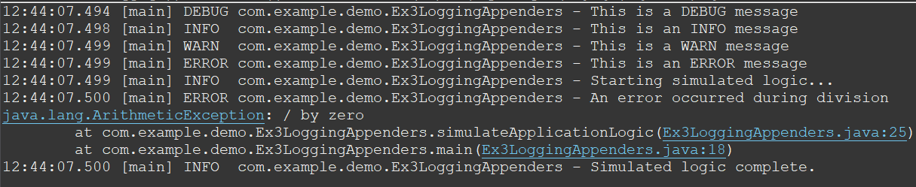

File:

